**Environmental DNA highlights the influence of salinity and agricultural run-off on coastal fish assemblages in the Great Barrier Reef region**

Aashi Parikh, Johan Pansu, Adam Stow, Michael St. J. Warne, Christine Chivas, Frederic Boyer, Paul Greenfield, Stuart Simpson, Rachel Smith, Jacob Gruythuysen, Geoffrey D. Carlin, Natalie Caulfield, Frederic Viard and Anthony A. Chariton

**SUPPLEMENTARY MATERIAL**

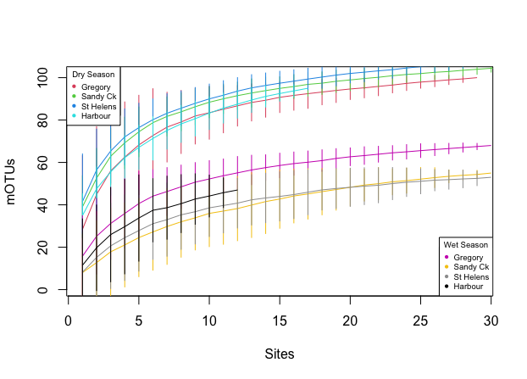 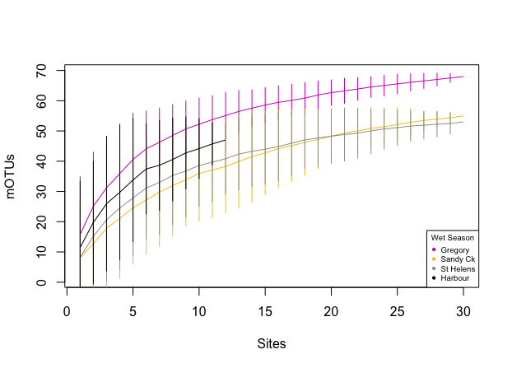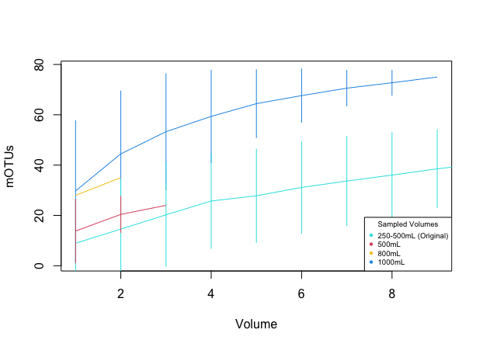

a.

b.

c.

**Figure S1.** Species accumulation curves generated for **a.** dry and wet season samples used in this study, **b.** only wet season samples used in this study, and **c.** the few samples during the wet season which were re-extracted at higher volumes, where 500mL, 800mL and 1000mL refers to the volume of water filtered in the re-extracts, and 250-500mL (Original) refers to the samples included in the study which correspond to the same sites as the re-extracted samples

**Figure S2.** Rarefaction curve of species richness accumulation at each location during the dry (2018) and wet (2020) season

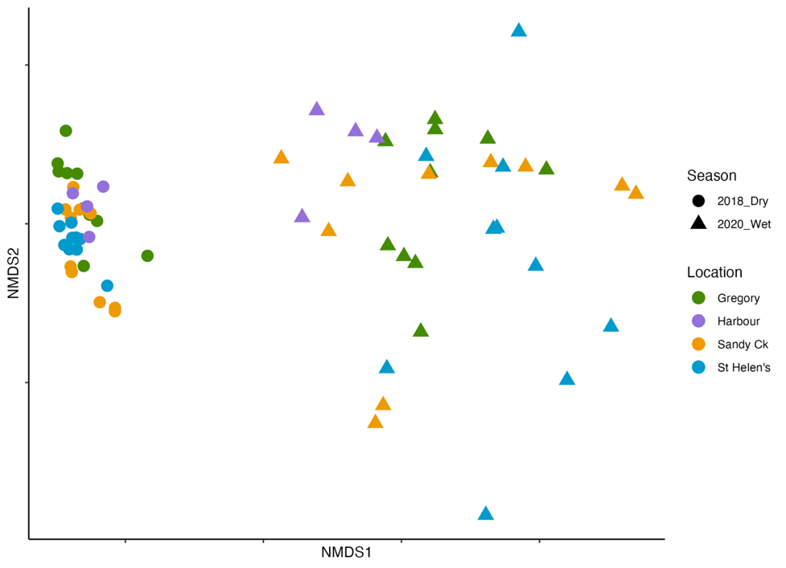

**Figure S3.** nMDS ordination plots of fish communities at different sites from the four locations during the dry (2018) and wet (2020) season, based on a Jaccard index of dissimilarity.

**Table S1.** GPS coordinates of the sample collection sites at the four study locations in the Mackay-Whitsunday region.

|  |  |  |  |
| --- | --- | --- | --- |
| **Location** | **Site** | **Latitude** | **Longitude** |
| Gregory River | S1 | -20.169808 | 148.463653 |
| Gregory River | S2 | -20.176668 | 148.480358 |
| Gregory River | S3 | -20.180098 | 148.481883 |
| Gregory River | S4 | -20.173833 | 148.484241 |
| Gregory River | S5 | -20.170892 | 148.475268 |
| Gregory River | S6 | -20.164633 | 148.468376 |
| Gregory River | S7 | -20.177986 | 148.455748 |
| Gregory River | S8 | -20.176744 | 148.449856 |
| Gregory River | S9 | -20.168007 | 148.442232 |
| Gregory River | S10 | -20.15874 | 148.433436 |
| St Helen's | S1 | -20.909632 | 148.839492 |
| St Helen's | S2 | -20.905901 | 148.841461 |
| St Helen's | S3 | -20.897115 | 148.828657 |
| St Helen's | S4 | -20.887556 | 148.830774 |
| St Helen's | S5 | -20.887579 | 148.842553 |
| St Helen's | S6 | -20.872732 | 148.843118 |
| St Helen's | S7 | -20.878308 | 148.811642 |
| St Helen's | S8 | -20.880415 | 148.82306 |
| St Helen's | S9 | -20.882432 | 148.829646 |
| St Helen's | S10 | -20.88342 | 148.834255 |
| Sandy Creek | S2 | -21.266959 | 149.16385 |
| Sandy Creek | S3 | -21.275074 | 149.175424 |
| Sandy Creek | S4 | -21.276282 | 149.180561 |
| Sandy Creek | S5 | -21.273441 | 149.188265 |
| Sandy Creek | S6 | -21.272302 | 149.192183 |
| Sandy Creek | S7 | -21.268295 | 149.198532 |
| Sandy Creek | S8 | -21.276926 | 149.163843 |
| Sandy Creek | S9 | -21.274582 | 149.168429 |
| Sandy Creek | S10 | -21.287364 | 149.179776 |
| Mackay Harbour | S1 | -21.112002 | 149.227472 |
| Mackay Harbour | S2 | -21.104729 | 149.235875 |
| Mackay Harbour | S3 | -21.106485 | 149.231084 |
| Mackay Harbour | S4 | -21.106485 | 149.225115 |

**Table S2.** Table of monitored pesticides and their limits of reporting

|  |  |  |  |
| --- | --- | --- | --- |
| **Pesticide** | **Limit of reporting (µg/L)** | **Pesticide** | **Limit of reporting (µg/L)** |
| 2,4-D | 0.02 | Imidacloprid | 0.02 |
| Ametryn | 0.01 | Isoxaflutole | 0.02 |
| Atrazine | 0.02 | MCPA | 0.01 |
| Bromacil | 0.02 | Metolachlor | 0.01 |
| Chlorpyrifos | 0.02 | Metribuzin | 0.02 |
| Diazinon | 0.01 | Metsulfuron-methyl | 0.02 |
| Diuron | 0.02 | Pendimethalin | 0.02 |
| Fipronil | 0.02 | Prometryn | 0.02 |
| Fluroxypyr | 0.05 | Simazine | 0.01 |
| Haloxyfop | 0.02 | Tebuthiuron | 0.01 |
| Hexazinone | 0.01 | Terbuthylazine | 0.01 |
| Imazapic | 0.01 | Tricopyr | 0.05 |

**Table S3.** Summary of environmental variables and nutrient concentrations in sampled water columns (mean ± SE) in the dry (2018) season. Values exceeding default trigger values from water quality guidelines are in bold text (ANZ, 2018). A complete listing of all measured parameters is available in Supplementary Sheet S4 (Nitrogen: Total Kjeldahl Nitrogen; Phosphorus: Total Kjeldahl Phosphorus; DOC: Dissolved Organic Carbon)

|  |  |  |  |  |  |  |  |
| --- | --- | --- | --- | --- | --- | --- | --- |
| Variable | Gregory | St. Helen's | Sandy Ck | Harbour | Guideline Value | ANOVA | |
| *F* value | *P* value |
| Chlorophyll (ug/L) | **2.2** ±0.2 | **3.2** ± 0.5 | **3.7** ±0.9 | 0.4 ± 0.06 | 2 | 3.81 | <0.05 |
| Salinity (PSU) | 39 ± 0.6 | 38.2 ± 0.2 | 37.5 ± 0.3 | 37.1 ± 0 | - | 4.05 | <0.05 |
| Turbidity (FNU) | 5.2 ± 1.7 | 3.1 ± 0.8 | 13.4 ± 6.9 | 0.8 ± 0.3 | 1-20 | 1.8 | ns |
| Nitrogen (mg/L) | **0.58** ± 0.06 | **0.65** ± 0.007 | **0.64** ± 0.005 | **0.63** ± 0.01 | 0.25 | 0.73 | ns |
| Phosphorus (mg/L) | **0.11** ± 0.008 | **0.11** ± **0.0**03 | **0.12** ± 0.002 | **0.12** ± 0.001 | 0.02 | 1.95 | ns |
| DOC (mg/L) | 1.92 ± 0.21 | 1.75 ± 0.1 | 1.24 ± 0.06 | 0.88 ± 0.03 | - | 9.42 | <0.001 |

**Table S4.** Summary of environmental variables and nutrient concentrations in sampled water columns (mean ± SE) in the wet (2020) season. Values exceeding default trigger values from water quality guidelines are in bold text (ANZ, 2018). A complete listing of all measured parameters is available in Supplementary Sheet S4 (Nitrogen: Total Kjeldahl Nitrogen; Phosphorus: Total Kjeldahl Phosphorus; DOC: Dissolved Organic Carbon)

|  |  |  |  |  |  |  |  |
| --- | --- | --- | --- | --- | --- | --- | --- |
| Variable | Gregory | St. Helen's | Sandy Ck | Harbour | Guideline Value | ANOVA | |
| *F* value | *P* value |
| Chlorophyll (ug/L) | **4.5** ±0.3 | **3.9** ±0.5 | **6.7** ±0.6 | **2.5** ±0.5 | 2 | 10.69 | <0.001 |
| Salinity (PSU) | 8.5 ± 3.01 | 3.4 ± 1.8 | 7 ± 3.1 | 32.6 ± 1.4 | - | 12.89 | <0.001 |
| Turbidity (FNU) | **67.8** ± 18.5 | **79.3** ± 35.7 | **35.5** ± 6.3 | **55.3** ± 24.5 | 1-20 | 0.67 | ns |
| Nitrogen (mg/L) | **0.92** ± 0.07 | **0.6** ± 0.05 | **0.92** ± 0.08 | 0.24 ± 0.01 | 0.25 | 14.8 | <0.001 |
| Phosphorus (mg/L) | **0.16** ± 0.017 | **0.08** ± 0.012 | **0.21** ± 0.036 | **0.07** ± 0.005 | 0.02 | 6.8 | <0.01 |
| DOC (mg/L) | 13.14 ± 1.87 | 9.62 ± 0.76 | 12.53 ± 1.37 | 1.85 ± 0.1 | - | 7.81 | <0.001 |

**Table S5.** List of pesticides removed from statistical analyses due to strong correlation

|  |  |
| --- | --- |
| **Removed pesticide** | **Correlated pesticide included in analysis** |
| Isozaflutole metabolite | Amicarbazone |
| Desethyl atrazine and 3,4-dichlorophenylurea (DCPU) | Atrazine |
| Metolachlor-OXA and fluroxypyr | Metolachlor |
| Asulam | Metribuzin |
| Imazapic | Hexazinone |

**Table S6.** Species of conservation value on the IUCN red list of threatened species (IUCN, 2021). Conservation status CR: Critically endangered, EN: Endangered, VUL: Vulnerable, NT: Near threatened.

|  |  |  |  |  |
| --- | --- | --- | --- | --- |
| Scientific name | Common name | Conservation status | Primer | Location detected |
| *Glaucostegus granulatus* | Sharpnose guitarfish | CR | Elas02 | All |
| *Glaucostegus typus* | Giant guitarfish | CR | Tele01 | All |
| *Rhynchobatus australiae* | White-spotted guitarfish | CR | Tele01, Elas02 | All |
| *Sphyrna lewini* | Scalloped hammerhead | CR | Tele01 | Gregory River |
| *Aetobatus narinari* | Spotted eagle ray | EN | Elas02 | All |
| *Eleutheronema tetradactylum* | Fourfinger threadfin | EN | Tele01 | Sandy Creek, St Helens, Harbour |
| *Himantura uarnak* | Reticulate whipray | EN | Elas02 | All |
| *Rhinoptera javanica* | Flapnose ray | EN | Elas02 | Gregory River |
| *Carcharhinus leucas* | Bull shark | VUL | Tele01, Elas02 | All |
| *Epinephelus fuscoguttatus* | Tiger grouper | VUL | Tele01 | All |
| *Pastinachus ater* | Cowtail stingray | VUL | Tele01, Elas02 | All |
| *Pateobatis jenkinsii* | Jenkin's whipray | VUL | Tele01 | All |
| *Urogymnus asperrimus* | Porcupine ray | VUL | Tele01, Elas02 | Sandy Creek, St Helens, Harbour |
| *Urogymnus granulatus* | Mangrove whipray | VUL | Tele01, Elas02 | Gregory River, St Helens, Harbour |
| *Dasyatis say* | Bluntnose stingray | NT | Elas02 | All |
| *Scomberomorus commerson* | Spanish mackerel | NT | Tele01 | Sandy Creek, Harbour |
| *Scomberomorus munroi* | Australian spotted mackerel | NT | Tele01 | Sandy Creek, Harbour |

*Bioinformatics processing:*

Bioinformatics processing of the raw 12S mtDNA metabarcoding data for Tele01 and Elas02 was carried out using the GHAP pipeline (Greenfield, 2017). Both datasets were processed separately using the same methods. Demultiplexed reads were end-trimmed to reduce the number of sequencing errors in the overlap regions, using a sliding window technique and a minimum acceptable quality score of 25. Each pair of trimmed reads files were merged to create files of full-length amplicon sequences using *usearch -mergepairs* (Edgar, 2010). High-quality amplicons from all samples (expected errors < 0.1) were then clustered using *usearch -unoise3* to generate a set of high-quality zero-radius sequences (zOTUs). The original amplicons for each sample were then mapped back onto these zOTU sequences to generate abundance counts for each zOTU for each sample, and these counts were used to create a zOTU/sample abundance matrix. The zOTU sequences were then compared to the MitoFish reference database using *usearch -ublast* to find the closest match, and the identity of this match was used to assign a taxonomic lineage for the sequence. The taxonomic assignments and the abundance matrix were finally merged to create zOTU tables for each primer pair, including taxonomy and read counts of samples matched to zOTUs. Any zOTU rows in these tables with less than 80% identity match to the MitoFish database were discarded.